Design Journal
Polishing a game

I have chosen the client game “Pew Pew” to expand on and polish. I chose this game because I feel that it has potential to be much better, and I have many ideas for things to add. I am hoping to add better sprites. I would like a more polished looking game, as well as a more polished feeling game. I plan to update the sprites to more HD textures. I also want to update how the player knows the time. Right now I have text saying “2 am” for example. I want to update this to make it more interesting somehow.
I want the player to get lost in the forest I’ve created. The game is simple and not too hard to understand. This means I need to add the challenge in the gameplay, rather than figuring out what to do. I will know if I’ve done this successfully or not by watching someone play the game and seeing if they get to the end with difficulty. I would hope that they find at least one aspect of the game challenging, but not unfair.

08/07- I have updated the textures for the ground and changed the buildings to trees. The whole game has a different feel. It has a whole new setting, but with the same gameplay. This took about 40 minutes to complete.

27/07- During the holidays, I’ve had time to think about what I’m going to do for this project in term 3. I have now done some tweaks to the coding. Zombies move faster, bullets move faster, this helps the game feel more challenging in a way that doesn’t require simply adding more enemies. This took about 20 minutes.

29/07- I have completely changed the player. He is not 100% top down with no animation and he faces the mouse cursor. This means the game has smoother movement and easier shooting. This has completely changed the game and has made me feel much better overall about the project. I have added a cave system. In level three a cave can be found. Once you enter it, you must make your way through the cave system by walking up to and using ladders. As you go deeper, more enemies spawn guarding each ladder. Once you reach the final ladder, it takes the player up into level 4, the final level, set in the forest again, but this time, the forest is crowded with zombies. Today I also added music which I have made from scratch at home on Ableton 11 using a launchpad. I decided it would be interesting to have my own music as the soundtrack for the game. I added a gunshot sound when the player shoots and I plan on adding walking noises too. All of this took about 3 hours. Darcy tested my game and found mentioned that I should add a more thorough tutorial. In agreement, I went ahead and added the controls to the existing tutorial. I also removed the lives system and made it a simple one hit kill dynamic where the zombies will instantly kill you. I did this because it simply makes the flow of the game feel smoother, and I felt it was too easy. I plan on adding a sneak mode to help sneak around zombies but doubt Ill have enough time to do this. If I had another two weeks I would add much more, but for now I am happy with what I’ve achieved.
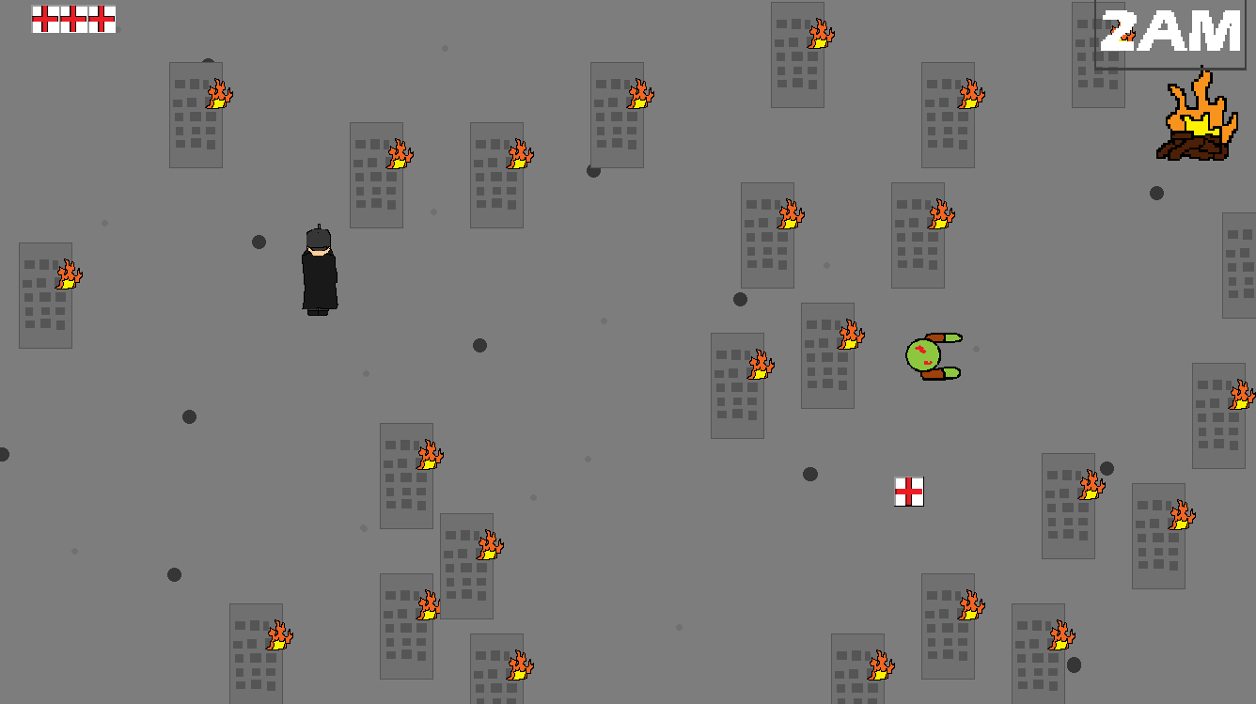

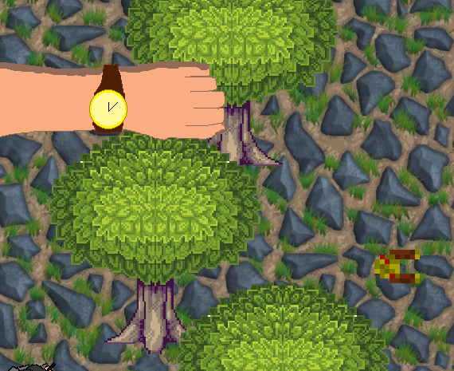
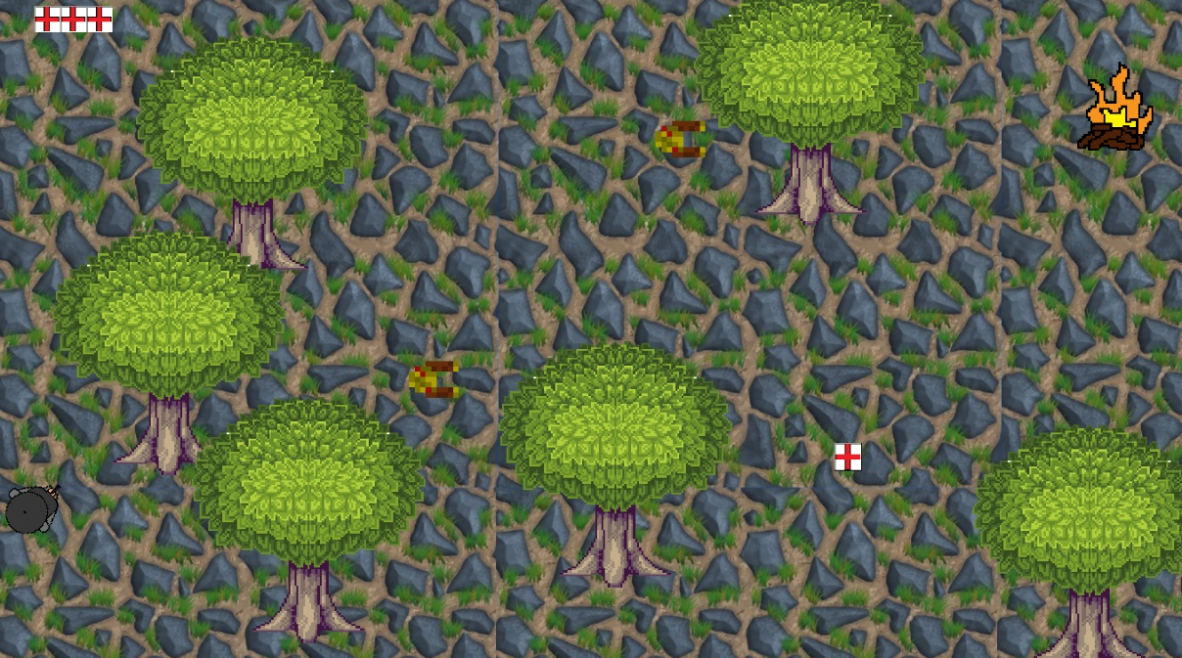
Here is an image of the watch I have implemented into each level. It shows the time of night in a unique way. This helps players know roughly how much progress they are making, which I think is rewarding compared to simply blindly playing, which works for some games, but in my opinion not for this one.
Here are two screenshots of the same level (level 1) before and after my changes. As you can see the game is completely different, the only thing that remains the same is the goal and genre.

