Design Journal

Date | Duration | Description
19/08/2022 | 3 hours | 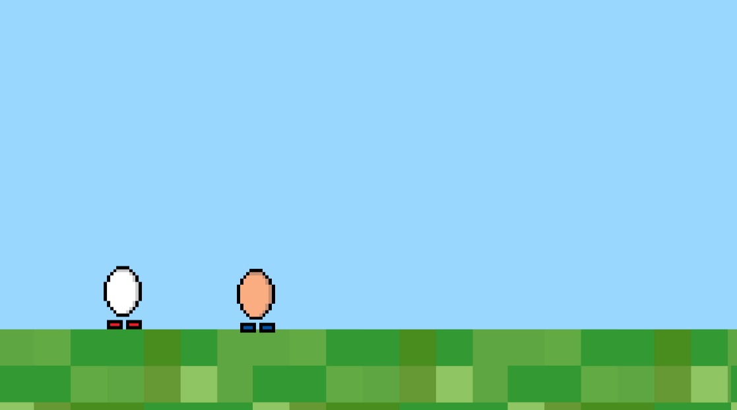  I have started on my egg game. I began by making sprites of eggs and animating them to walk left and right. Once I did that, I created a light blue sky for the background of the game and some grass for the floor. After doing some research, I figured out how to make both the eggs jump and have programmed separate controls for each so that it is not a local 2-player game.
24/08/2022 | 1.5 hours | 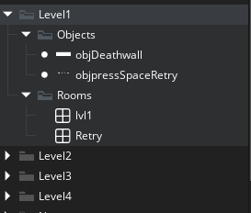  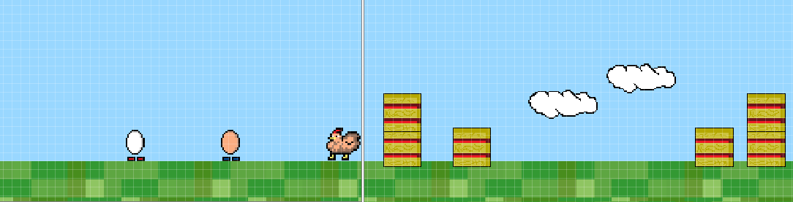  I have now changed the size of the room to give the players more space and so that the game functions as I want it to. I duplicated the room twice and created three levels. I drew a sprite of a white rectangular wall and decided that the wall would chase the players. I coded the wall to move to the right on creation and I added collision coding with the eggs & wall to make it so that the players can die. This means, of course, that I need a retry button or something similar. I made a death screen and added the option to restart the level after death. Then I drew sprites of a chicken, haybales and a red flag. I created objects with their corresponding sprite. The chickens and hay are obstacles to jump over while the players run from the wall, while the flag takes you to the next level after a collision with one of the eggs. I then added a fourth level and created a cloud object that floats in the sky. The players can jump on the clouds. I asked Ned to play the game with me and it worked well. The white egg got stuck on objects once or twice but that may have been due to simply not jumping at the right time. Finally, I spent the remaining time sorting my objects and rooms into folders and subfolders so that navigating my way around is much easier.
26/08/2022 | 3 hours | 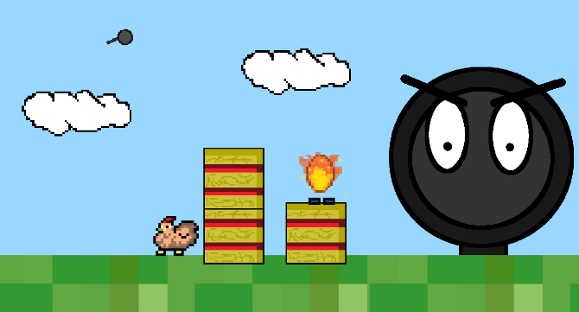  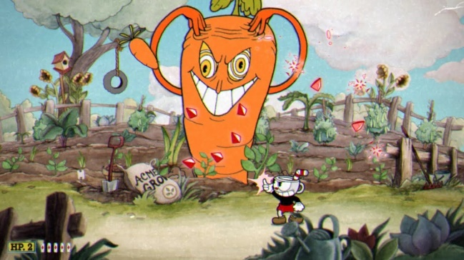  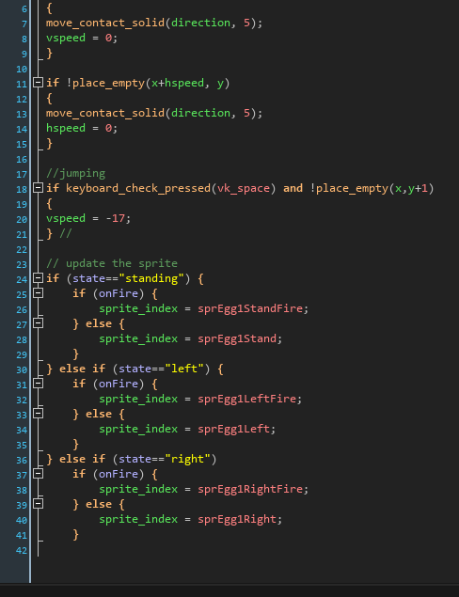  I dedicated my time this lesson to making a boss battle level for the game, inspired by cuphead. I haven’t yet finished it but I have made a very good start and used my time well. The boss is a large angry frying pan. I plan on giving both eggs super powers. I am giving player 1 fire and player 2 ice. You defeat the boss by standing on him while using your ability to drain his health, however, you need to dodge the “flying pans” that come at you in the air, but you cannot jump while your ability is active. This means you need to plan out and choose when to deal damage and when to focus on avoiding the flying pans, because if even one touches you, the level is over. All I have done right now is create the room, add the boss, some obstacles and given player 1 the fire ability. I can see this taking one or two more lessons to complete, but now that I’ve learnt how to tackle the fire powers, the ice powers should be much easier for me. I ran into a big issue where my egg wouldn’t move to the right, but fixed it by adding a state = “right” and implementing that into the step event to help the object move.
28/08/2022 | 2 hours | I spent this time at home fixing up some of the levels, making them feel smoother to play through by moving some things around within the room. I used GML code give the player 2 egg its ice powers, the same way as player 1 egg. I was very proud of figuring that out. Another thing I did which I was proud of was making it so that the eggs cannot jump while using their abilities which will be a mechanic heavily influencing the levels. I have made a healthbar for the boss frying pan which drains slowly while the eggs stand on it. I am currently trying to figure out how to make it so that it only depletes health when the eggs are touching it and using their abilities. After I figure that out I can work on making the rest of the boss battle function.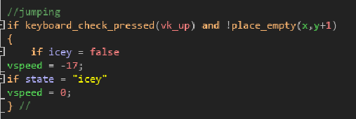
31/08/2022 | 1.5 hours | 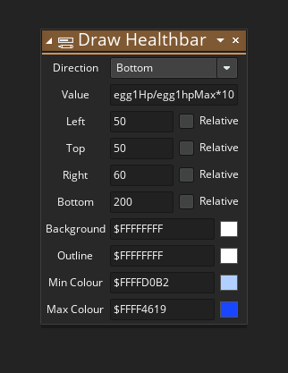  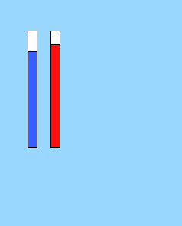  In this session, I worked on adding healthbars to the players and making it so that they only do damage to the boss frying pan while their abilities are active. This took some trial and error with using GML code, which I am very new to, but I eventually got it working which I’m proud of. I made both eggs a healthbar that sit in the top left of the screen and visualises the loss of health vertically.
7/09/2022  (happy birthday Kani) | 1.5 hours | 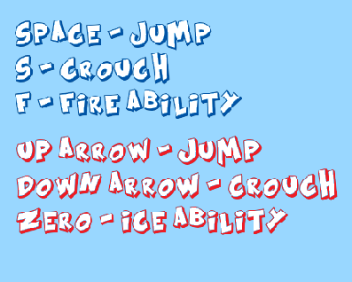  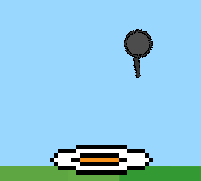  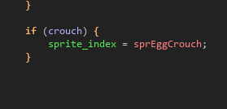  I spent this time creating a crouching ability for the eggs so that I can impliment more depth into the levels. I created a sprite of a cracked egg and wrote some coding that changes the state into “crouch” for the egg(s) when a certain key is pressed. After this, I decided to include some controls on the side of the screen for the boss fight by using a draw GUI event for both eggs.
9/09/2022 | 3 hours | 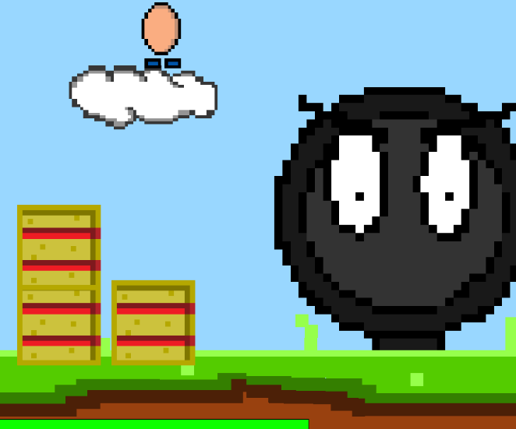  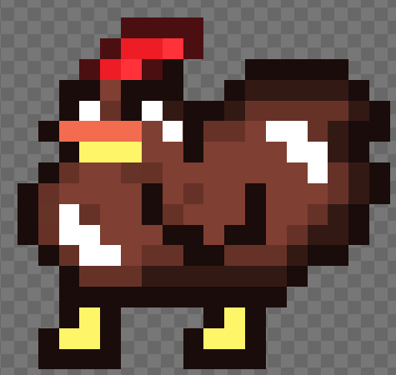  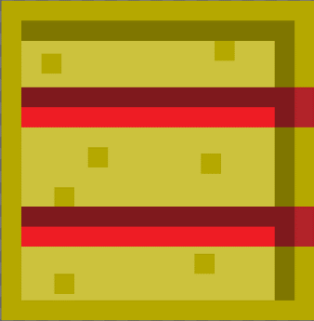  I spent this session updating the sprites for a few specific things. These include the chicken, haybale, clouds, flying pans, the main boss frying pan and the groudn texture. I am very proud of my ground texture, it looks exactly how I wanted it to. My main goal was to make them look more simplistic. I lowered their resolutions and used a smaller variety of colours.
11/09/2022 | 5 hours | 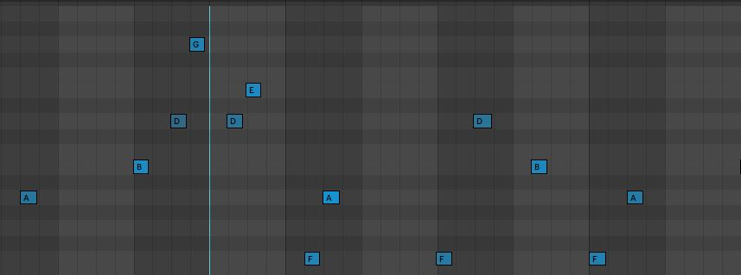  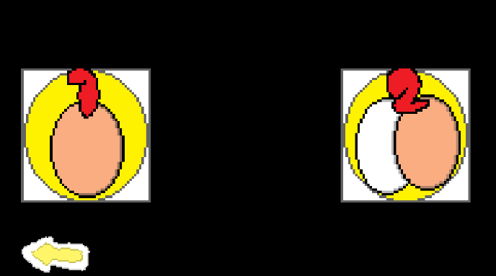  This time, I created a single player mode, so that you can play through the game without needing someone else. This will make play testing much easier for everybody. I made a main menu that allows you to select whether you want 1 or 2 players. I then decided to make the levels feel more unique. I did this by changing the background colour for each level so that it looks like it is getting later and later into the night. On level 4, I decided to change the ground sprite to add pools of blood and yolk. I then replaced the chickens on level four with empty broken egg shells. Then, I changed the wall sprite on every level to the frying pan that you fight at the end, making it much less random. Finally, I decided to make some music for the game so I went into ableton and created a jingle that I made play on the main menu. Each level has its own variation of the tune as it gets progressively spookier as the night goes on.
23/09/2022 | 3 hours | 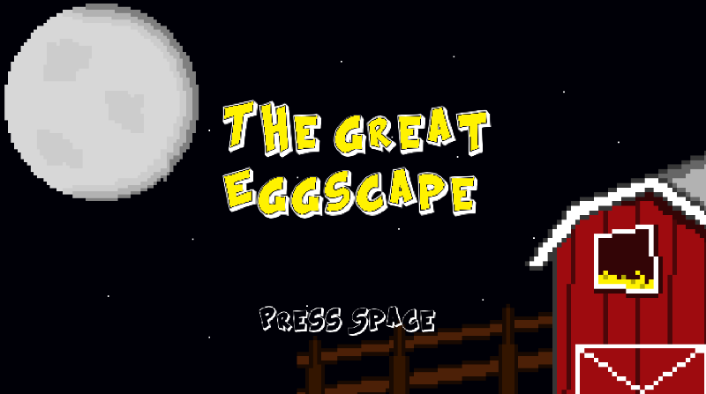  I have just polished up the main menu with some more fun visuals to look at, setting the tone of the game and defining a theme. I also fixed a glitch I found where if you crouch in the air, you can keep running and jumping as if you werent crouched, but using the crouch sprite.
30/09/2022 | 3 hours | 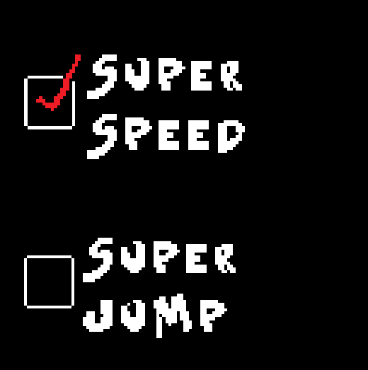  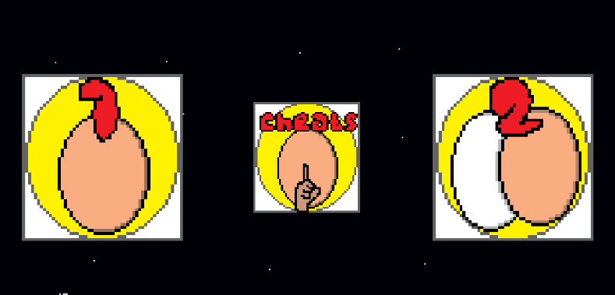  I have spent this time fixing up small bugs that I have found, mainly through the people who have tested the game for me. One of these bugs include getting stuck between a haybale and the bos frying pan during the boss battle. I quickly fixed this by readjusting where the haybale sat on the ground. I also added some more flying pans as obstacles onto level 2 and 3 so that theyre more challenging and interesting. I have added small improvements to the menu, specifically the player amount selection. When the cursor hovers over the tile, it enlarges. I added a cheats menu to allow the player to have some fun messing around with exaggerated mechanics of the game. I currently have only two cheats. These are super speed and super jump. I plan to add a “ghost mode” where the player(s) can run through all obstacles.
26/10/2022 | 1.5 hours | I removed the cheat menu due to bugs and decided to print out some testing protocol sheets I made on word. I have had 6 people test my game and have all filled out the sheet. With the results, I polished up all the issues we found and now have a much smoother game.

